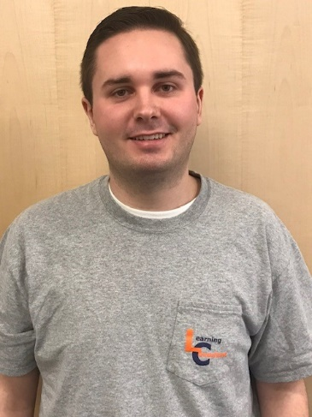

Peyton Gasink

I’m a junior majoring in Software Engineering and the vice president of the Auburn Jungle. My hobbies include going to Auburn basketball games, biking around Auburn, spending time with friends, and stomping Hunter in basketball.

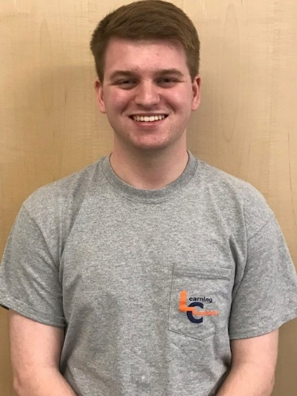

Hunter Simpson

I am a Senior studying Software Engineering. Hobbies include hanging out with friends, watching too much tv, and beating Peyton at racquetball.

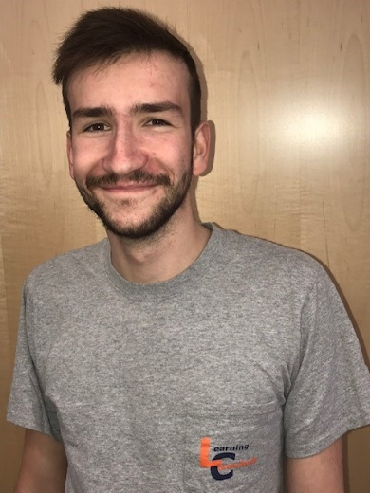

Jeremy Newman

Jeremy Newman is a senior from Ridgewood, New Jersey majoring in Political Science and Economics with a minor in Philosophy & Religion. When not sitting at one of the front tables in Mell and gazing longingly at the original façade of the library (an architectural favorite of Jeremy and many visiting alumni) or producing high quality and visually stunning instructional videos to convey helpful information and better the utilization of the buildings’ technology, Jeremy enjoys playing various musical instruments, playing basketball, and reading non-fiction.

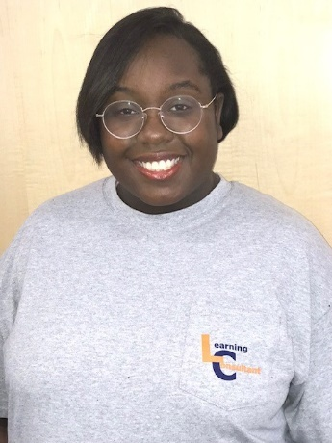

Rulisha Binion

My name is Rulisha Binion and I’m a Junior majoring in Creative Writing with a Graphic Design minor. I enjoy cooking, studying the Korean language, starting on drawings I will never finish, and playing video games.

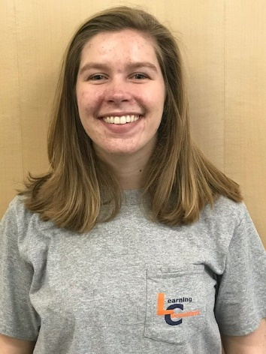

Logan Holyfield

Hi all, I'm a junior majoring in Business Analytics. Outside of work, I like to try new foods (cooking and eating), watch the news + various tv shows, read new books, and snuggle my kitty.

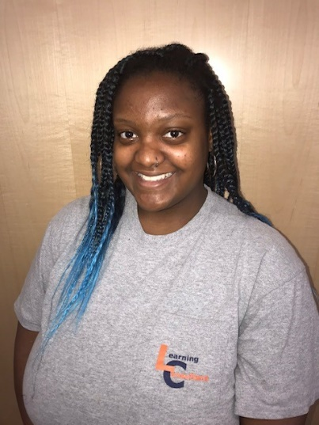

Angel Brown

I am a Junior in the Medical Lab Science major. I am also a resident assistant. I love to crochet.

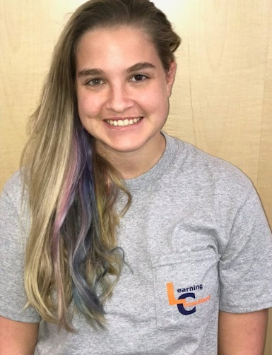

Brooke Johnson

I am a Freshman that is a Chemistry major. I like to Sing, Dance and swim!

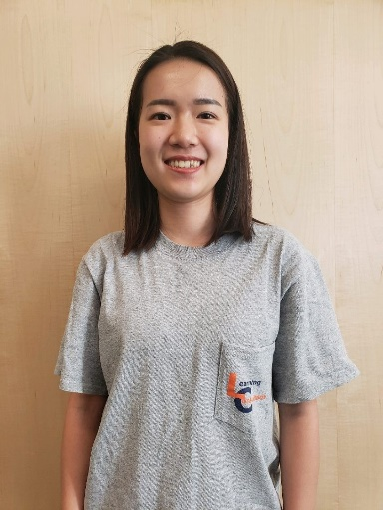

Esther Xiang

hey I’m Esther, major in Business Administration and minor in Supply Chain. I am crazy about travel and watching movies! My biggest dream is to have my own cat.

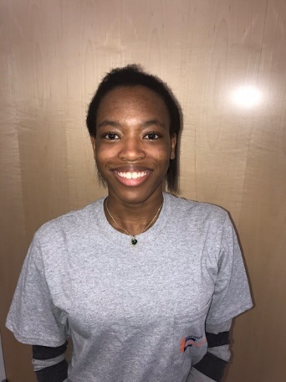

Kira B – Keep same intro, change classification

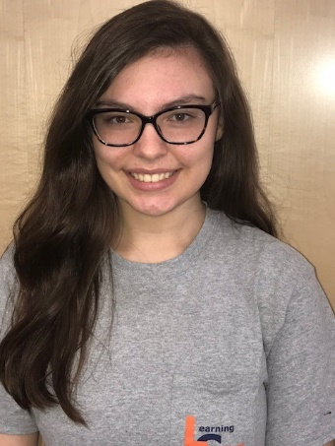

Sarah Staley – Keep same intro, change classification