Last known editor: Thilina Mendis 09/20/2023
Last known location:
server: mallard.auburn.edu
path: /export/vol2/httpd/htdocs/academic/provost/online/GlossaryTemplate
Last known ID: Amy Conway

Tutorial using ECON 2030 as an example:
Step1: Set up the spreadsheet.
The spreadsheet needs to be a google doc spreadsheet with three columns: Term, Definition, Tier. The terms need to be in alphabetical and the tier needs to be set to 1.
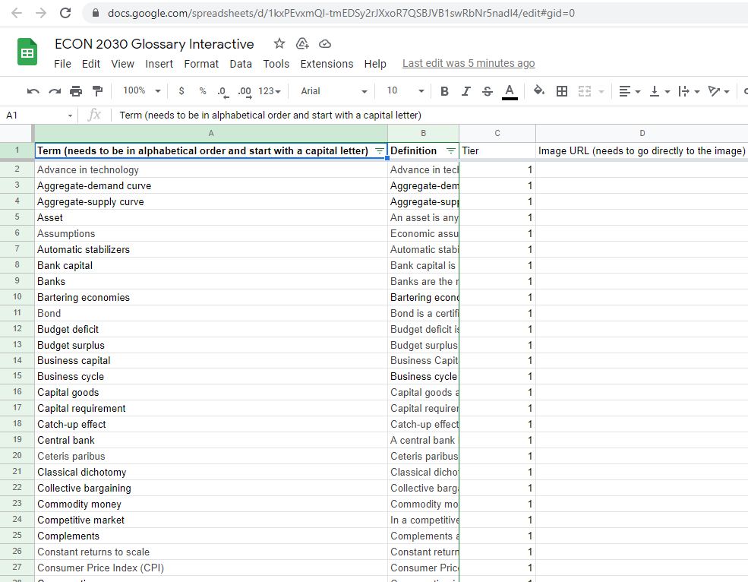
Note: Tier does not appear to do anything but if there is a not a value for tier then the application does not work.
You can use without the Tier and URL – Temp2
Another Note: There is code for displaying images, but I have not tested it. (Joshua Webb 2022)
Step2: Publicly host the spreadsheet
The spreadsheet now needs to be made into a public csv file. First go to file->share->Publish to web.
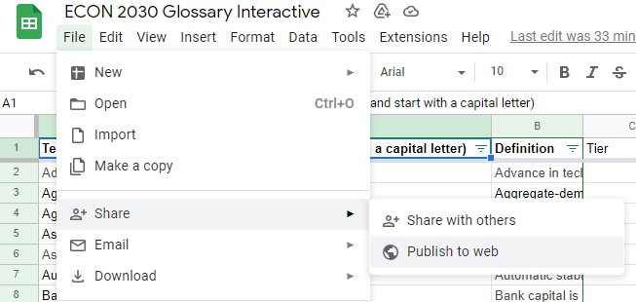
Then make sure to select the spreadsheet page, which in this example is ECON 2030 Terms (NOT the entire document), select .csv, then make sure the box is checked to automatically republish and finally click publish.
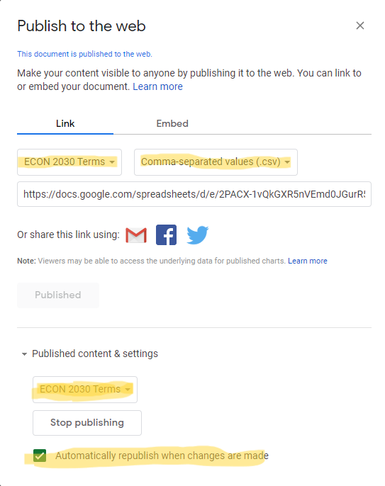

Step3: Download and edit the glossary template
/export/vol2/httpd/htdocs/academic/provost/online/GlossaryTemplate
To download the glossary, you will first need permission to access the mallard.auburn.edu server. Once you have access to the server navigate to the following path: /export/vol2/httpd/htdocs/academic/provost/online/GlossaryTemplate. Now download a copy of the glossary located in this folder to your computer. 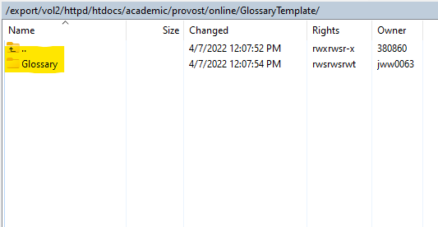
Now you are going to need a code editing software of some kind, I prefer to use visual studio code as it works on all operating systems. Once you have downloaded the glossary folder along with visual studio code you are going to open the glossary folder inside of VSCode. 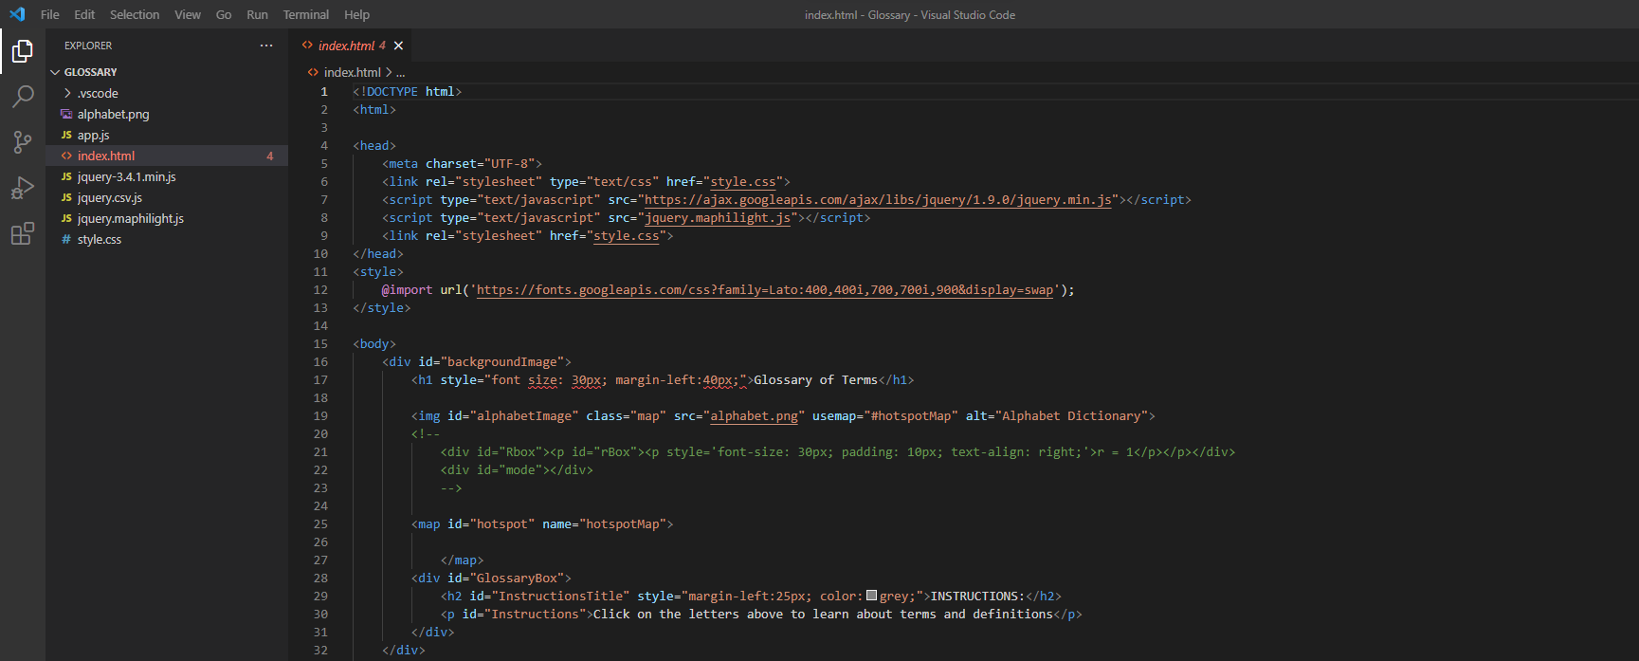
With the folder open go to the index.html file as seen in the picture. Lastly copy the link to the published csv from earlier and paste it over the previous link on line 64.
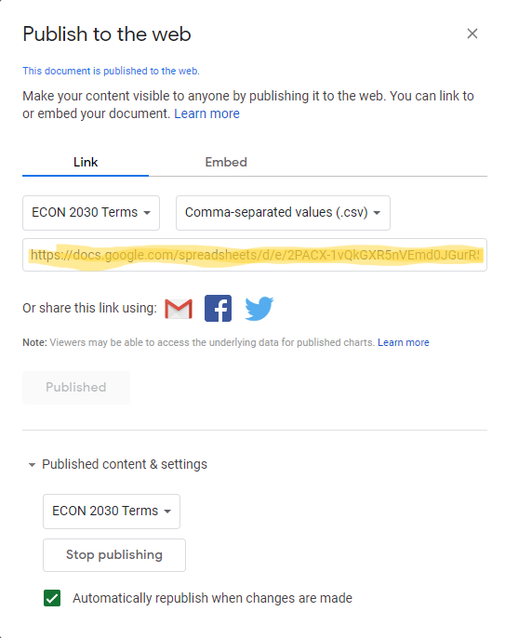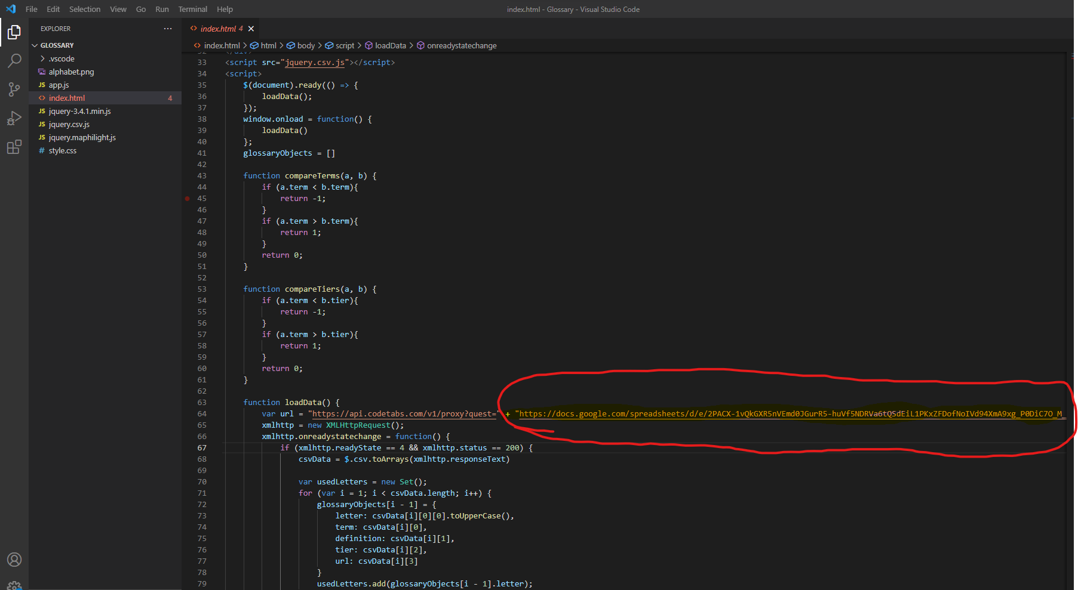
Now save the edited glossary.

Step4: Upload the glossary and iframe into the desired course.
For our last step you are going to start by moving the newly edited glossary back to the mallard.auburn.edu server except now we want to move it to a class specific folder. In our example here we will move the glossary into the ECON 2030 folder at the following path: /export/vol2/httpd/htdocs/academic/provost/online/ECON2030.
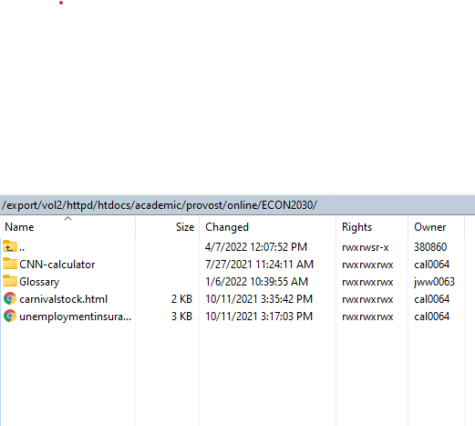
Now that the glossary is being hosted on the server with the proper set of terms we can create an iframe in our canvas course. For the iframe source we need to link to the index.html file of our glossary. So our properly constructed iframe will look like:
<iframe style="overflow: hidden;" src="https://auburn.edu/academic/provost/online/ECON2030/Glossary/index.html" width="100%" height="3200"></iframe>
Note: When linking to things on the mallard server we replace the /export/vol2/httpd/htdocs with https://auburn.edu when creating a link instead.
Example of finished product
