# Auburn First Enrollment Tutorial

## Enrollment Tutorial, Step 1

In your web browser, navigate to <https://aub.ie/aufirst-parents>.

Click on the “Enroll” button.

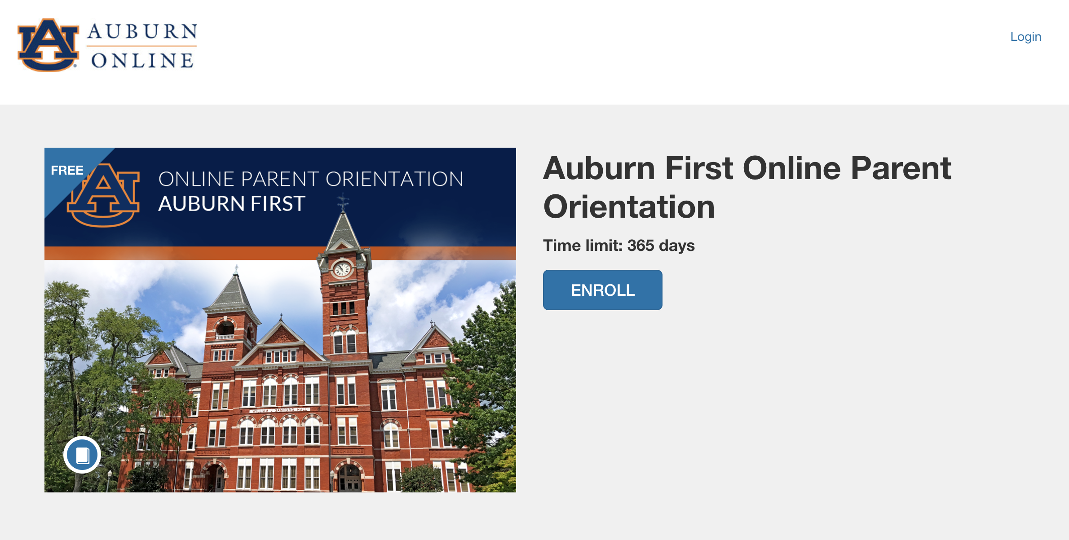

## Enrollment Tutorial, Step 2

Enter your full name and email address and click the “Enroll in Course” button.

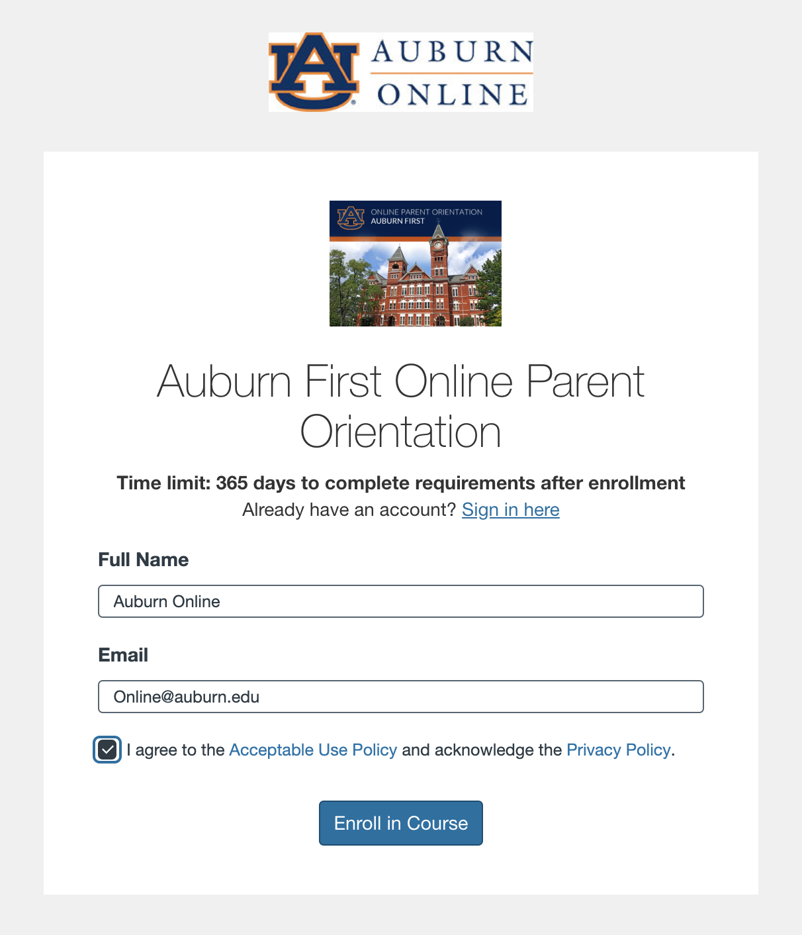

## Enrollment Tutorial, Step 3

You will be prompted to check your inbox to confirm your registration.

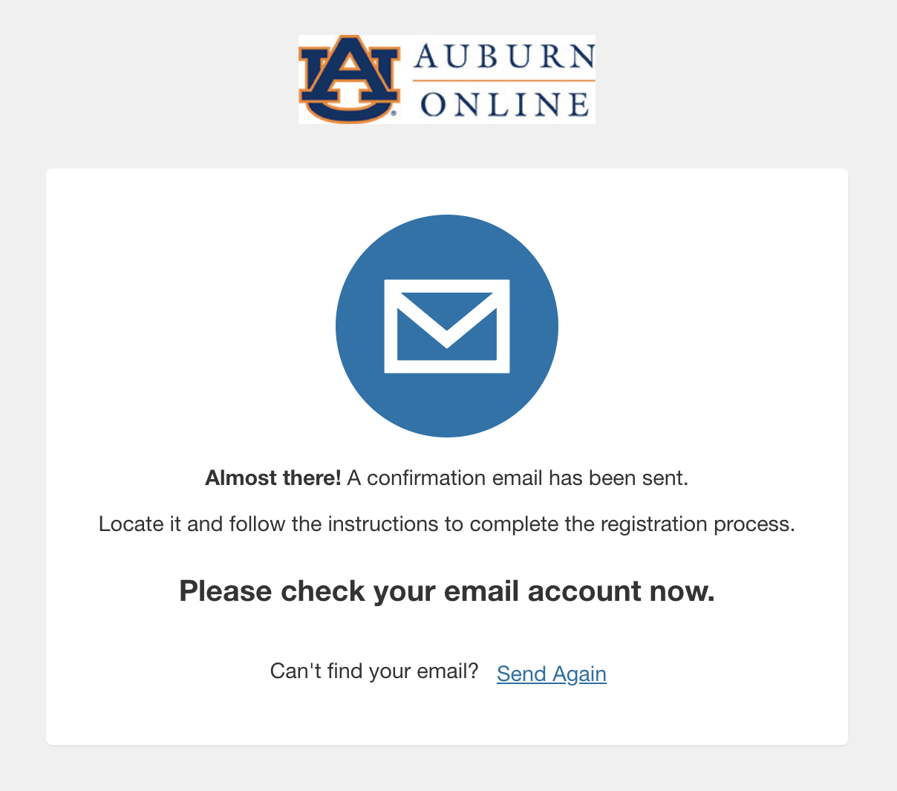

## Enrollment Tutorial, Step 4

Now you have access to the course.

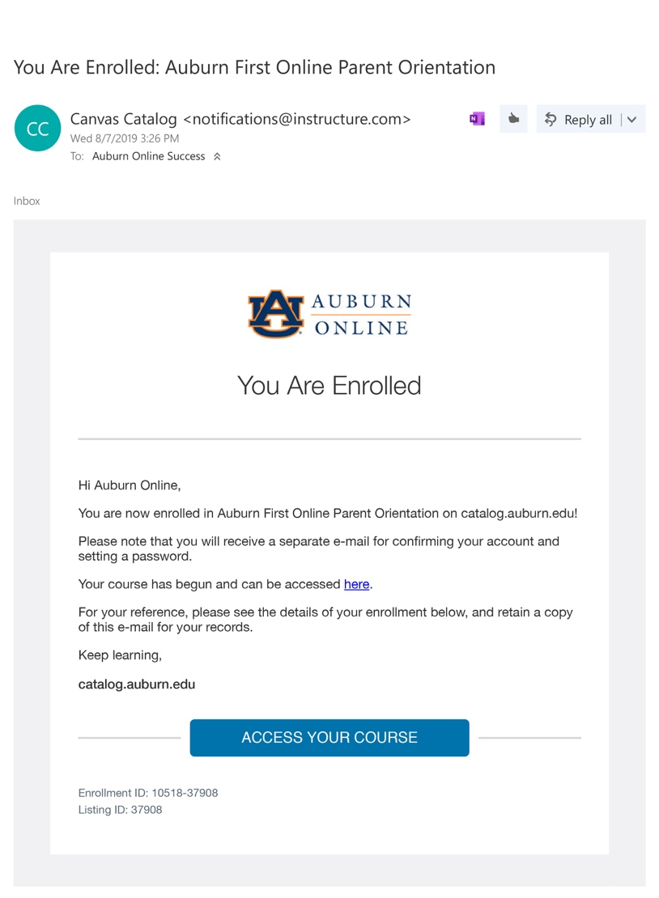

## Enrollment Tutorial, Step 5

Complete your registration.

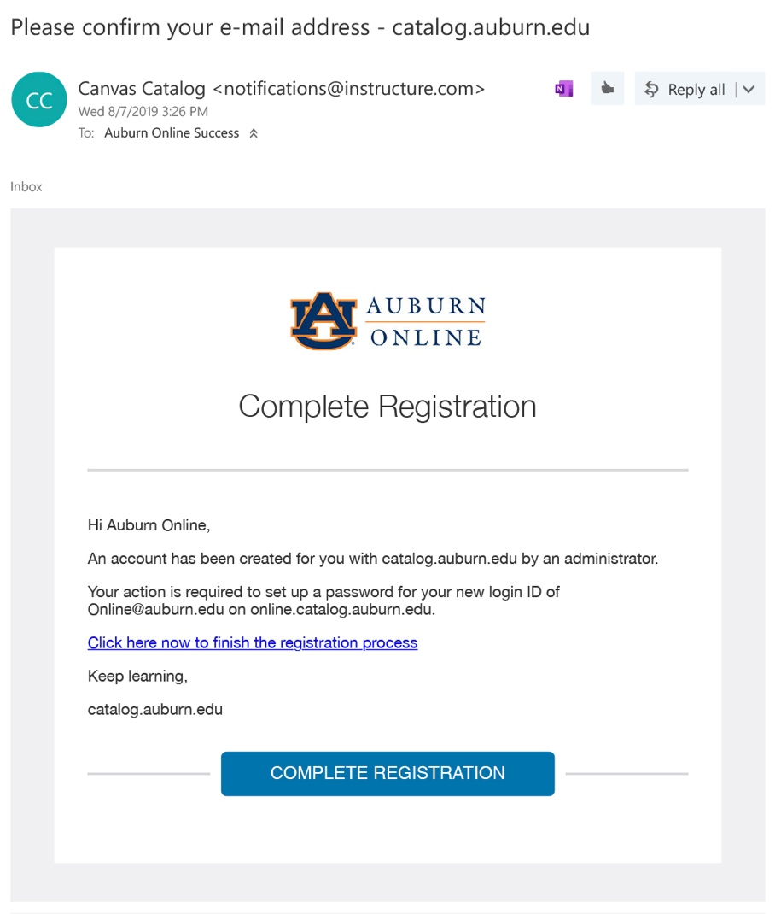

## Enrollment Tutorial, Step 6

Setup a password for your new login ID for Auburn Catalog.

Note: Be sure that your password is at least 8 characters.

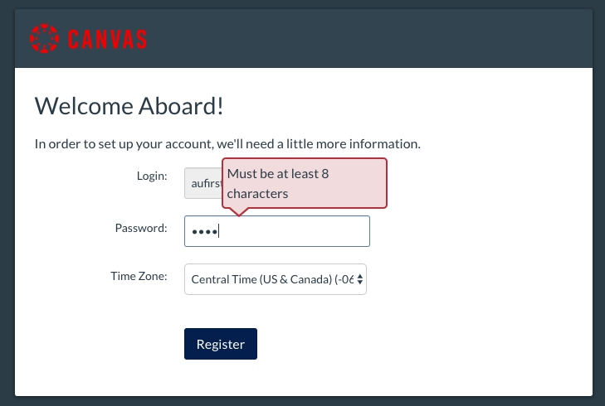

## Enrollment Tutorial, Step 7

Visit <https://auburncatalog.instructure.com/> to login to your account at any time.

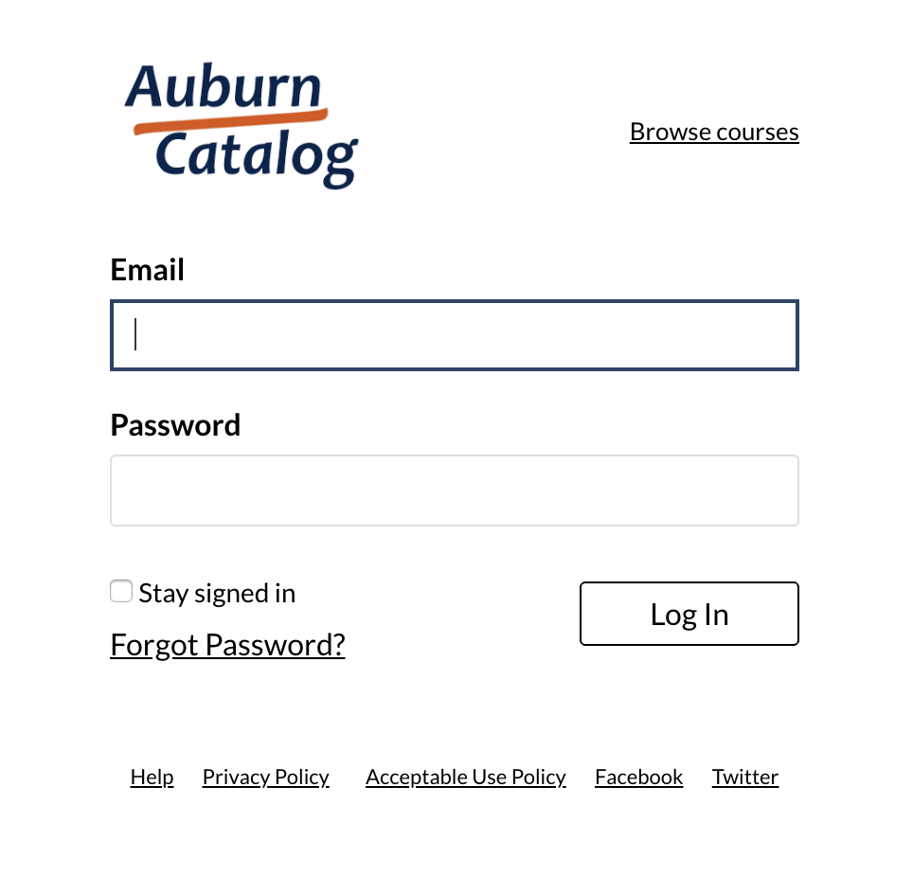

## Enrollment Tutorial, Step 8

Click on the “Go To Course” button.

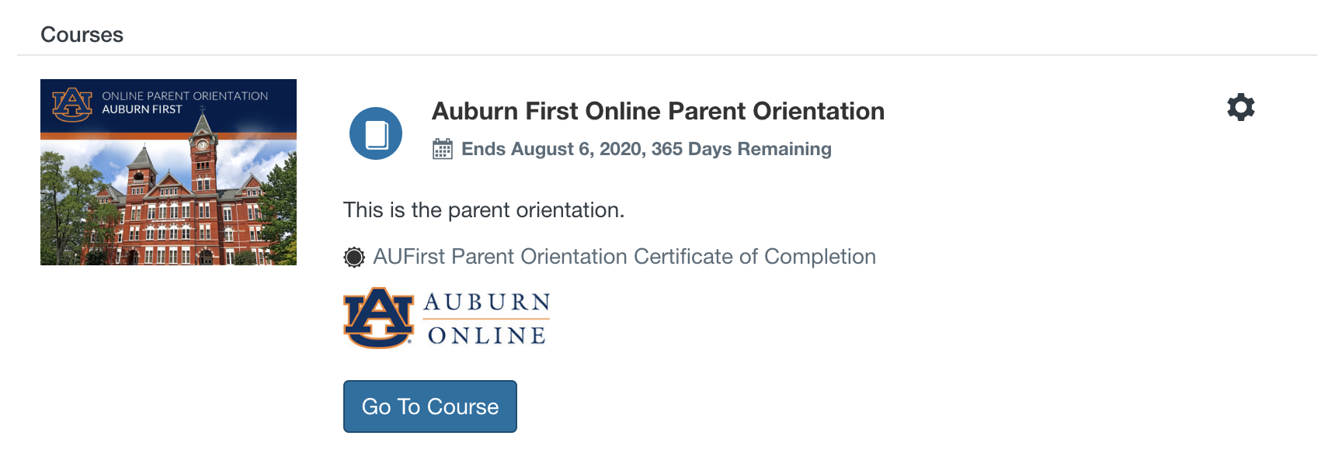

## Enrollment Tutorial, Step 9

Now you can begin the course!

