|  |  |  |  |
| --- | --- | --- | --- |
| |  |  |  | | --- | --- | --- | | Seal | Biography | Flag | |
| ***U N I T E D   S T A T E S   A I R   F O R C E*** |
|  |

**MAJOR JULIO C. WALKER**

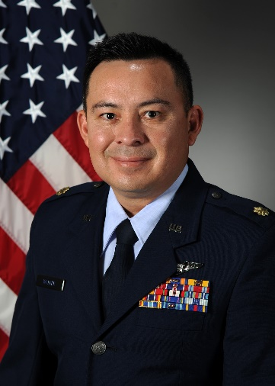Major Julio C. Walker is an Assistant Professor of Aerospace Studies, and Operations Officer, AFROTC Det 005, Auburn University, Auburn AL. In this capacity, he instructs junior level courses on leadership, supervision, mentoring, ethics, and professionalism. He has the responsibility for training, mentoring, and preparing cadets to become Air Force Officers. He previously served as Program Manager of Artificial Intelligence (AI) Integration, 453d Electronic Warfare Squadron, leading efforts to incorporate AI into global threat change detection “flagging” operations, technical SIGINT, and near real-time electromagnetic spectrum analysis. Major Walker previous instructor experience includes serving as the Chief instructor EW for Detachment 1, WPC, at the Tactical Leadership Programme, Albacete Spain. His primary duty was teaching EW and ISR to NATO partner nations, while maintaining combat mission ready status as a mission crew commander on the RC-135V/W. Furthermore, he culminated his time at Offutt AFB as a school house instructor/evaluator Electronic Warfare Officer (EWO) and Mission Crew Commander (MCC) on the RC-135 V/W RIVET JOINT. He accomplished additional specialized training such as Non-Kinetics Operations and Execution, Electronic Warfare Coordination and Planning, Air Operations Center Operations, and Contingency Warfare Planning Course graduate.

Maj Walker received his commission through Air Force ROTC at Texas State University. His assignments include various flying and staff assignments at squadron and MAJCOM level, including USAFE HQ at Ramstein AB. Major Walker has served in Operations IRAQI FREEDOM, ENDURING FREEDOM, INHERENT RESOLVE and RESOLUTE SUPPORT. He is an electronic warfare officer with over 2600 hours and 1300 combat hours in the RC-135V/W RIVET JOINT and 12 deployments to the Middle East, Japan, South America, Red Flag, and Europe

# EDUCATION

2004 Bachelors of Fine Arts, Texas State University, San Marcos, TX

2005 Combat Systems Officer Training, Randolph AFB, TX

2006 Electronic Warfare Training, Randolph AFB, TX

2011 Squadron Officer School, Maxwell AFB, TX

2013 Masters Human Relations, The University of Oklahoma, Norman, OK

2016 Air Command and Staff College, Maxwell AFB, AL (correspondence)

# ASSIGNMENTS

1. June 2005 - December 2005, Student, Undergraduate Combat Systems Officer, Randolph AFB, TX.

2. December 2005 - July 2006, Electronic Warfare Officer School, Randolph AFB, TX.

3. July 2006 - February 2012, RC-135 Rivet Joint EWO, 38 Reconnaissance SQ, Offutt AFB, NE.

4. Feb 2012 – Feb 2014, Instructor EWO, Evaluator EWO, 338th Combat training SQ, Offutt AFB, NE.

5. Feb 2014 - June 2017, Action Officer Staff, USAFE-AFAFRICA HQ, Ramstein AB, Germany.

6. June 2017 - July 2019, Chief Instructor EW, ACAD Branch, TLP, Detachment 1, WPC, Albacete, Spain

7. July 2019 – July 2021, Program Manager, 453 Electronic Warfare SQ, JBSA Lackland, TX

# 8. July 2021- Present, Instructor Assistant Professor of Aerospace Studies, AFROTC Detachment 005,

# Auburn University, AL

# FLIGHT INFORMATION

Rating: Senior Navigator / EWO Specialty Flight hours: 2657

Aircraft flown: RC-135V/W, RC-135U, Alpha Jet, CASA C-101

**MAJOR AWARDS AND DECORATIONS**

Meritorious Service Medal

Air Medal

Air Force Commendation Medal

Meritorious Unit Award

AF Outstanding Unit Award

Combat Readiness Medal

National Defense Service Medal

Afghanistan Campaign Medal

Global War on Terrorism Expeditionary Medal

Global War on Terrorism Medal

Remote Combat Effects Campaign Medal

Nuclear Deterrence Operations Service Medal

**EFFECTIVE DATES OF PROMOTION**

Second Lieutenant March 02, 2005  
First Lieutenant February 18, 2007  
Captain February 18, 2009  
Major July 1, 2015

(Current as of June 2021)