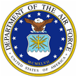 |  | 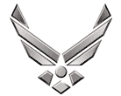

U N I T E D S T A T E S A I R F O R C E

MAJOR JULIO C. WALKER

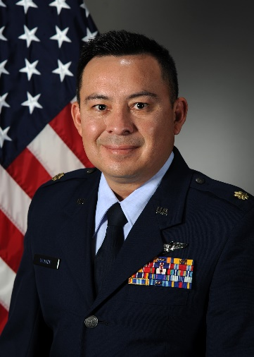
Major Julio C. Walker is an Assistant Professor of Aerospace Studies, and Operations Officer, AFROTC Det 005, Auburn University, Auburn AL. In this capacity, he instructs junior level courses on leadership, supervision, mentoring, ethics, and professionalism. He has the responsibility for training, mentoring, and preparing cadets to become Air Force Officers. He previously served as Program Manager of Artificial Intelligence (AI) Integration, 453d Electronic Warfare Squadron, leading efforts to incorporate AI into global threat change detection “flagging” operations, technical SIGINT, and near real-time electromagnetic spectrum analysis. Major Walker previous instructor experience includes serving as the Chief instructor EW for Detachment 1, WPC, at the Tactical Leadership Programme, Albacete Spain. His primary duty was teaching EW and ISR to NATO partner nations, while maintaining combat mission ready status as a mission crew commander on the RC-135V/W. Furthermore, he culminated his time at Offutt AFB as a school house instructor/evaluator Electronic Warfare Officer (EWO) and Mission Crew Commander (MCC) on the RC-135 V/W RIVET JOINT. He accomplished additional specialized training such as Non-Kinetics Operations and Execution, Electronic Warfare Coordination and Planning, Air Operations Center Operations, and Contingency Warfare Planning Course graduate.

Maj Walker received his commission through Air Force ROTC at Texas State University. His assignments include various flying and staff assignments at squadron and MAJCOM level, including USAFE HQ at Ramstein AB. Major Walker has served in Operations IRAQI FREEDOM, ENDURING FREEDOM, INHERENT RESOLVE and RESOLUTE SUPPORT. He is an electronic warfare officer with over 2600 hours and 1300 combat hours in the RC-135V/W RIVET JOINT and 12 deployments to the Middle East, Japan, South America, Red Flag, and Europe

EDUCATION
2004 Bachelors of Fine Arts, Texas State University, San Marcos, TX
2005 Combat Systems Officer Training, Randolph AFB, TX
2006 Electronic Warfare Training, Randolph AFB, TX
2011 Squadron Officer School, Maxwell AFB, TX
2013 Masters Human Relations, The University of Oklahoma, Norman, OK
2016 Air Command and Staff College, Maxwell AFB, AL (correspondence)

ASSIGNMENTS
1. June 2005 - December 2005, Student, Undergraduate Combat Systems Officer, Randolph AFB, TX.
2. December 2005 - July 2006, Electronic Warfare Officer School, Randolph AFB, TX.
3. July 2006 - February 2012, RC-135 Rivet Joint EWO, 38 Reconnaissance SQ, Offutt AFB, NE.
4. Feb 2012 – Feb 2014, Instructor EWO, Evaluator EWO, 338th Combat training SQ, Offutt AFB, NE.
5. Feb 2014 - June 2017, Action Officer Staff, USAFE-AFAFRICA HQ, Ramstein AB, Germany.
6. June 2017 - July 2019, Chief Instructor EW, ACAD Branch, TLP, Detachment 1, WPC, Albacete, Spain
7. July 2019 – July 2021, Program Manager, 453 Electronic Warfare SQ, JBSA Lackland, TX

8. July 2021- Present, Instructor Assistant Professor of Aerospace Studies, AFROTC Detachment 005,

Auburn University, AL

FLIGHT INFORMATION
Rating: Senior Navigator / EWO Specialty Flight hours: 2657
Aircraft flown: RC-135V/W, RC-135U, Alpha Jet, CASA C-101

MAJOR AWARDS AND DECORATIONS
Meritorious Service Medal
Air Medal
Air Force Commendation Medal
Meritorious Unit Award
AF Outstanding Unit Award
Combat Readiness Medal
National Defense Service Medal
Afghanistan Campaign Medal
Global War on Terrorism Expeditionary Medal
Global War on Terrorism Medal
Remote Combat Effects Campaign Medal
Nuclear Deterrence Operations Service Medal

EFFECTIVE DATES OF PROMOTION
Second Lieutenant March 02, 2005
First Lieutenant February 18, 2007
Captain February 18, 2009
Major July 1, 2015

(Current as of June 2021)

