

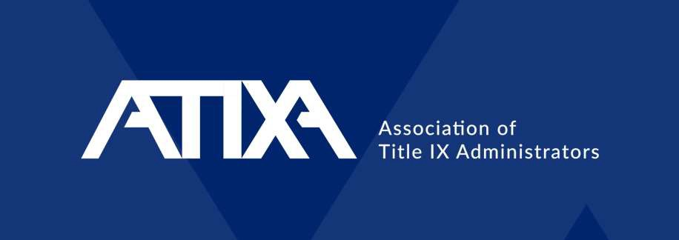

January 23, 2025

To Sign or Not to Sign? Evaluating Title IX Complaints as an Institution/District
Brett Sokolow, J.D., Chair, ATIXA
Kayleigh Baker, J.D., Senior Consultant, TNG

© 2025 Associati n of Title IX Administrators

1



Today’s Presenters
Kayleigh Baker, J.D.
Senior Consultant, TNG
Brett A. Sokolow, J.D.
Chair, ATIXA


© 2025 Association of Title IX Administrators 2



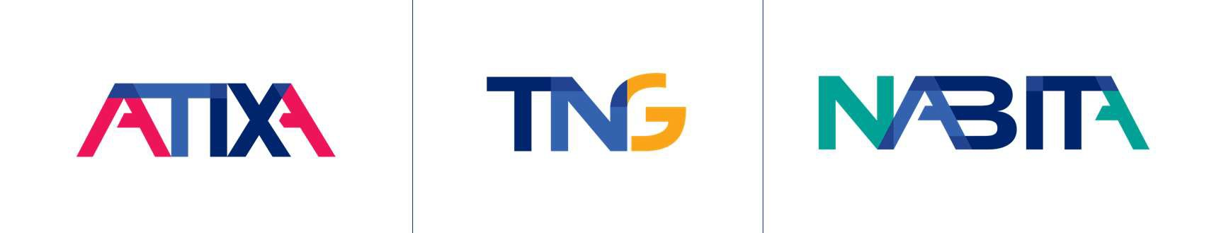
Any advice or opinion provided during this training, either privately or to the entire group, is never to be construed as legal advice or an assurance of compliance. Always consult with your legal counsel to ensure you are receiving advice that considers existing case law in your jurisdiction, any applicable state or local laws, and evolving federal guidance.
(610) 993-0229 | inquiry@tngconsulting.com | www.tngconsulting.com
3


Regulatory Authority
4
Under the 2020 Title IX Regulations, a formal complaint is a document filed by a complainant or signed by the Title IX Coordinator

© 2025 Association of Title IX Administrators

Title IX Coordinator Signs the Complaint

When a Title IX Coordinator does initiate an investigation, it is important to remember:
- The Title IX Coordinator does not become the Complainant
  - The Complainant is the person who allegedly experienced the harm
  - The Complainant, even if they choose not to sign or participate, still has all rights afforded to Complainants throughout the process
- The Title IX Coordinator should notify the Complainant before issuing the NOIA
- The Complainant must still be named in the NOIA
- The Complainant may but does not have to participate and should be offered supportive measures throughout the process
- Memo to File

When to Sign: PPTVWM

In limited circumstances, a TIXC should sign a formal complaint even if the Complainant declines to do so
Factors that likely indicate an ongoing risk of harm include:
- Pattern

Other Considerations for TIXC Signing a Formal Complaint
- Employee Respondent
- Complainant who is not P/ATP
- Predation
- Threat
- Violence
- Weapons
- Minors

When to Sign: Additional Factors

- Although no longer in effect, the 2024 Regulations provided eight non-exhaustive considerations for Title IX Coordinators when determining whether to initiate an investigation
- The Complainant’s request for no School/District action
- The Complainant’s reasonable safety concerns regarding initiating a Complaint
- The risk that additional acts of sex discrimination would occur if a Complaint were not pursued
- The severity of the alleged sex discrimination, including whether the discrimination, if established, would require the removal of a Respondent from the school/district or imposition of another disciplinary sanction to end the discrimination and prevent its recurrence
- The age and relationship of the Parties, including whether the Respondent is a School/District employee
- The scope of the alleged sex discrimination, including information suggesting a pattern, ongoing discrimination, or discrimination alleged to have impacted multiple individuals
- The availability of evidence to assist a Decision-maker in determining whether sex discrimination occurred
- Whether the School/District could end the alleged sex discrimination and prevent its recurrence without initiating its Formal Grievance Process

When to Sign: VRA

- The use of a Violence Risk Assessment (VRA) can also help a Title IX Coordinator determine whether to sign a formal complaint

  - Helps determine potential violence or dangerousness toward a person, group, or system
Violence Risk Assessment
  - Explores various risk factors and protective elements in a comprehensive manner
  - Not predictive, but an estimate of the factors that make it more or less likely the individual will engage in violence

Special Considerations: IPV

- IPV cases vary widely; however, often Practitioners may consider signing formal complaint when allegations of dating violence or domestic violence are made, even absent one or more PPTVWM factor
  - ATIXA recommends reconsidering this approach
- Initiating a complaint in the most precarious IPV scenarios, against the wishes of a Complainant, has a heightened risk of placing the Complainant in harm’s way
  - Abusers may blame and try to punish complainants through additional violence
  - Abusers may view attempts to seek help as threatening, and because of feeling cornered, may act desperately
- In many situations, it may be wise to prioritize developing a safety plan to help a Complainant prepare to file a complaint, rather than potentially escalating the situation before a Complainant has made the decision to report or leave the situation

What if you don’t sign?

- Title IX still requires institutions to stop, prevent, and remedy
  - Obligation not to act with “deliberate indifference”
- Continue to offer supportive measures
- Allegations cannot be sent to another office (Building Principal, Student Conduct, HR) to adjudicate the allegations under a different process if the allegations meet the definition of sexual harassment under Title IX
- No timeline to file a complaint
  - Facts may also change that could cause the Title IX Coordinator to reach a different decision
- Memo to file



Other considerations

- Multiple Complainants
- Complainants requesting to be excluded from process
- Informal Resolution
- Dismissal/Change in Circumstances
- 2024 Regulations and Legal challenges



Thank you!
Kayleigh Baker, J.D., Senior Consultant, TNG kayleigh.baker@tngconsulting.com
Brett A. Sokolow, J.D., Chair, ATIXA brett.sokolow@tngconsulting.com
© 2025 Association of Title IX Administrators 12

