Studying Stellar Populations:
The Hertzsprung-Russell Diagram
Objectives
After creating an actual H-R diagram, several trends should be obvious among the stars based on their luminosity class. Using statistical information on the 'stellar population' can reveal the story of the stars. This exercise provides an understanding of the story behind the stars.

Introduction
The efforts of E. Hertzsprung and H.N. Russell led to the discovery of the relationship between the luminosity and surface temperature of the stars. This discovery would go on to be the foundation for the distance determination method of spectroscopic parallax.
Early in the 20th century, two astronomers independently discovered a certain pattern that all stars seemed to follow. Ejnar Hertzsprung, a Danish astronomer, made a plot of color versus luminosity for all stars with well determined parallax measurements (1911). Two years later, an American astronomer named Henry N. Russell plotted the absolute magnitude against spectral class. As you have probably already learned, absolute magnitude and luminosity are related by the equation:
where the M’s are the absolute magnitudes of object 1 and 2, and the L’s are the luminosity’s of object 1 and 2 respectively. Usually, other stars are considered object two while our Sun is object one since we can find the luminosity and absolute magnitude of the Sun with much more certainty. Also, the spectral class and color are both equivalents and can both be shown in terms of the blackbody temperature of the individual stars. By observing the dominant wavelength of light or electromagnetic radiation from an ideal source (a star is a very ideal blackbody source), you can use Wien’s law to determine the temperature of the source:
If you heat up a piece of metal to high temperature, it would first start to glow red and progress to white and finally glowing blue. At lower temperature, an ideal object will glow with longer wavelengths (red light = 6500 angstroms). When temperatures are increased enough, the emitted light’s wavelength shortens (blue = 4000 angstroms).
The graphs produced independently by Hertzsprung and Russell showed something remarkable. Instead of seeing a scatter graph with points all of over the chart, there were definite areas where all the stars seemed to group together. Somehow the luminosity of a star and its temperature were related [figure 1].
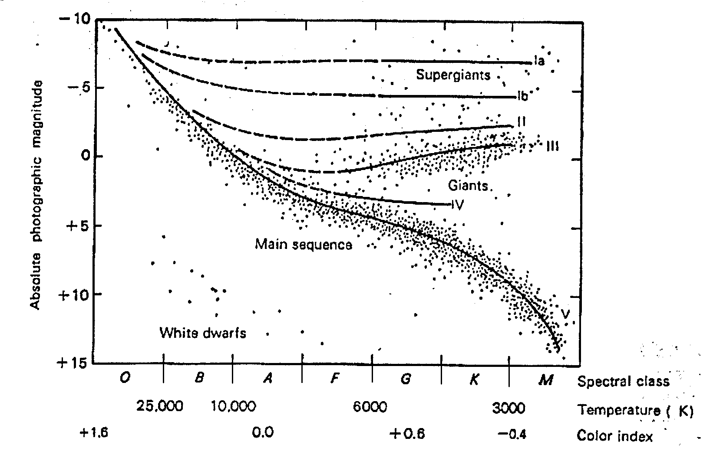
Figure 1
It has been shown through observational data of many stars that the more massive a star, the more luminous it is. If you observe the H-R diagram on the cover of the lab, it is clear that there are fewer luminous stars as compared to the less luminous ones. In terms of the diagram, there are more stars on the lower end than the higher end of the main sequence on the absolute magnitude axis (which directly corresponds to luminosity). The luminosity of a star is determined by the core’s nuclear fusion process. A certain amount of energy is generated by the star’s fusion reactions, and that amount depends on the temperature of the core. The higher the core temperature, the higher rate of fusion and energy output which results in a higher luminosity. The factor that affects core temperature is the amount of gravitational pressure or mass of the star. Thus, a more massive star will be more luminosity. Data compiled from the studies of binary star systems done by D.M. Popper calibrated the relationship now known as the mass-luminosity relationship.
The question still remains about the existence of the main sequence. The H-R diagram is a statistical picture of most of the stars we know about in the sky. It shows us the number of stars in various states of both luminosity and temperature. The lifetimes of stars depend on their initial masses. A more massive star will have a higher temperature, and will ‘burn’ its nuclear fuel at a higher rate than a smaller star. So, when we look at the star’s in the Milky Way, there are more stars on the main-sequence because stars spend more time there. Giant stars exist for a smaller period of time, and are therefore more rare. The existence of the main-sequence is a statistical description of the time evolution of stars.
Later research by Adams and Kohlschutter at the Mt. Wilson Observatory showed that it was possible to tell not only the temperature of a star by its spectra, but also whether it was an average star (called main-sequence), a giant, or a white dwarf. Several classifications of stars were identified from the H-R diagram, called luminosity classes. They were given a designation as follows:
Ia Brightest supergiants
Ib Less luminous supergiants
II Bright giants
III Giants
IV Subgiants (between giants and main sequence)
V Main sequence stars
VI Subdwarfs (lie slightly below the main sequence)
VII White dwarfs
For most stars, it is possible to find there distances using a something called the method of spectroscopic parallaxes. By observing a star’s spectra, you can determine its color (or maximum wavelength) and what luminosity class it falls into. Knowing λmax and using Wien’s law, you can find the temperature of the star. Now look at figure 2.
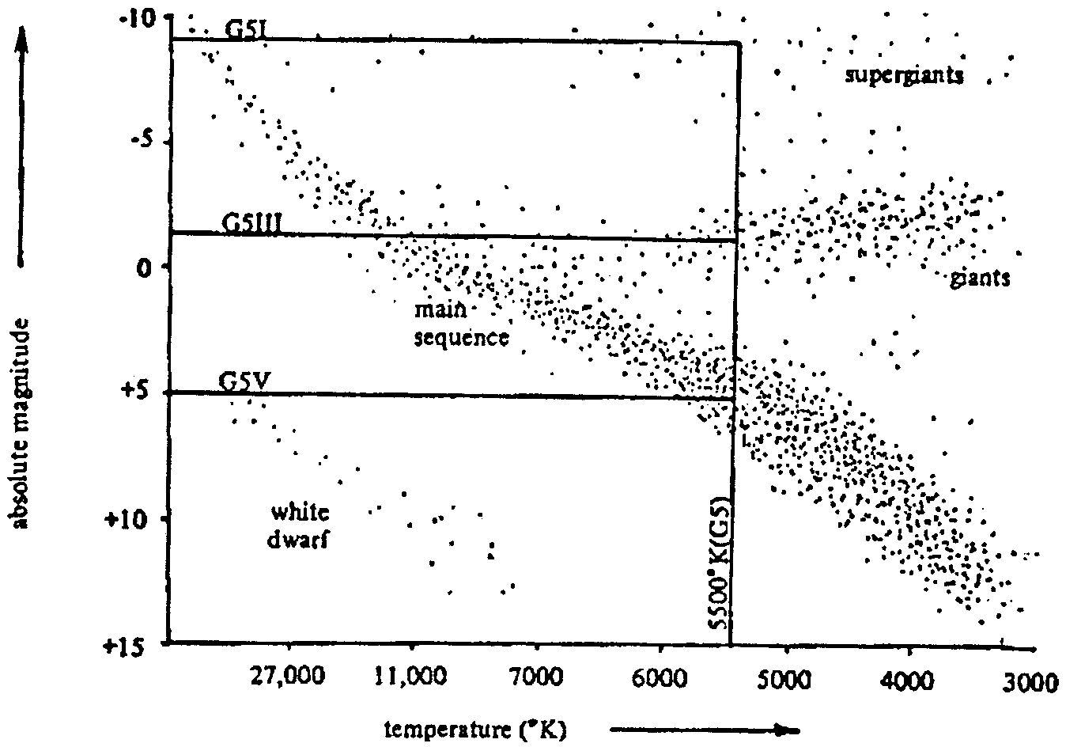
Figure 2
Knowing a star’s luminosity class and temperature, you can see where that star would be located on the H-R diagram. Tracing over to the vertical axis gives you the absolute magnitude. Finally, using the equation for the distance modulus (which comes from the inverse-square law), you can find the distance to the star!
m - M = 5 log (D/10) where m = apparent magnitude,
M = absolute magnitude, and D = distance in parsecs.
By simply solving for D, the distance to the star will be revealed. Using a logarithm function:
Astronomers used more physics to show another piece of information that could be found about stars. Using Stefan’s law, the following relationship is seen:
where σ = 5.67 x 10-7
The luminosity can then be expressed as the energy multiplied by the area, which can be written as, A = 4πR2. Thus, luminosity is:
L = 4πR2 (σ T4 ). Now, you can find the radius of a star!

Table 10.1

The Brightest Stars, as Seen from the Earth
Adapted from Norton's 2000.0, 18th edition (copyright 1989, Longman Group UK)

Common Name | Scientific Name | Distance (light years) | Apparent Magnitude | Absolute Magnitude | Spectral Type
Sun |  | - | -26.72 | 4.8 | G2V
Sirius | Alpha CMa | 8.6 | -1.46 | 1.4 | A1V
Canopus | Alpha Car | 74 | -0.72 | -2.5 | A9II
Rigil Kentaurus | Alpha Cen | 4.3 | -0.27 | 4.4, 5.7 | G2V, K1V
Arcturus | Alpha Boo | 34 | -0.04 | 0.2 | K1.5III
Vega | Alpha Lyr | 25 | 0.03 | 0.6 | A0V
Capella | Alpha Aur | 41 | 0.08 | -.7, 9.5 | G5III, M0III
Rigel | Beta Ori | ~1400 | 0.12 | -8.1 | B81a
Procyon | Alpha CMi | 11.4 | 0.38 | 2.6 | F5IV
Achernar | Alpha Eri | 69 | 0.46 | -1.3 | B3V
Betelgeuse | Alpha Ori | ~1400 | 0.50 (var.) | -7.2 | M2Ib
Hadar | Beta Cen | 320 | 0.61 (var.) | -4.4 | B1III
Acrux | Alpha Cru | 510 | 0.76 | -4.0, -3.5 | B0.5I, B1V
Altair | Alpha Aql | 16 | 0.77 | 2.3 | A7V
Aldebaran | Alpha Tau | 60 | 0.85 (var.) | -0.3 | K5III
Antares | Alpha Sco | ~520 | 0.96 (var.) | -5.2 | M1.5Ia
Spica | Alpha Vir | 220 | 0.98 (var.) | -3.2 | B1V
Pollux | Beta Gem | 40 | 1.14 | 0.7 | K0III
Fomalhaut | Alpha PsA | 22 | 1.16 | 2.0 | A3V
Becrux | Beta Cru | 460 | 1.25 (var.) | -4.7 | B0.5III
Deneb | Alpha Cyg | 1500 | 1.25 | -7.2 | A2Ia
Regulus | Alpha Leo | 69 | 1.35 | -0.3 | B7V
Adhara | Epsilon CMa | 570 | 1.50 | -4.8 | B2II
Castor | Alpha Gem | 49 | 1.57 | 1.2, 1.4 | A1V, A2V
Gacrux | Gamma Cru | 120 | 1.63 (var.) | -1.2 | M3.5III
Shaula | Lambda Sco | 330 | 1.63 (var.) | -3.5 | B1.5IV

Table 10.2

The Closest Stars to the Earth
Adapted from Norton's 2000.0, 18th edition (copyright 1989, Longman Group UK)

Common Name | Scientific Name | Distance (light years) | Apparent Magnitude | Absolute Magnitude | Spectral Type
Sun |  | - | -26.72 | 4.8 | G2V
Proxima Centauri | V645 Cen | 4.2 | 11.05 (var.) | 15.5 | M5.5V
Rigil Kentaurus | Alpha Cen A | 4.3 | -0.01 | 4.4 | G2V
 | Alpha Cen B | 4.3 | 1.33 | 5.7 | K1V
Barnard's Star |  | 6.0 | 9.54 | 13.2 | M3.8V
Wolf 359 | CN Leo | 7.7 | 13.53 (var.) | 16.7 | M5.8V
 | BD +36 2147 | 8.2 | 7.50 | 10.5 | M2.1V
Luyten 726-8A | UV Cet A | 8.4 | 12.52 (var.) | 15.5 | M5.6V
Luyten 726-8B | UV Cet B | 8.4 | 13.02 (var.) | 16.0 | M5.6V
Sirius A | Alpha CMa A | 8.6 | -1.46 | 1.4 | A1V
Sirius B | Alpha CMa B | 8.6 | 8.3 | 11.2 | A0White dwarf
Ross 154 |  | 9.4 | 10.45 | 13.1 | M3.6V
Ross 248 |  | 10.4 | 12.29 | 14.8 | M4.9V
 | Epsilon Eri | 10.8 | 3.73 | 6.1 | K2V
Ross 128 |  | 10.9 | 11.10 | 13.5 | M4.1V
 | 61 Cyg A (V1803 Cyg) | 11.1 | 5.2 (var.) | 7.6 | K3.5V
 | 61 Cyg B | 11.1 | 6.03 | 8.4 | K4.7V
 | Epsilon Ind | 11.2 | 4.68 | 7.0 | K3V
 | BD +43 44 A | 11.2 | 8.08 | 10.4 | M1.3V
 | BD +43 44 B | 11.2 | 11.06 | 13.4 | M3.8V
Luyten 789-6 |  | 11.2 | 12.18 | 14.5 | M5 White dwarf
Procyon A | Alpha CMi A | 11.4 | 0.38 | 2.6 | F5IV
Procyon B | Alpha CMi B | 11.4 | 10.7 | 13.0 | A7 White dwarf
 | BD +59 1915 A | 11.6 | 8.90 | 11.2 | M3.0V
 | BD +59 1915 B | 11.6 | 9.69 | 11.9 | M3.5V
 | CoD -36 15693 | 11.7 | 7.35 | 9.6 | M1.3V

Table 10.3

25 Random Stars Chosen from Gemini

Common Name | Scientific Name | Distance (light years) | Apparent Magnitude | Absolute Magnitude | Spectral Type
Sun |  | - | -26.72 | 4.8 | G2V
 | 46 | 218 |  | -0.1 | K2III
 | Kappa | 146 |  | 0.3 | G8III
 | 69 | 253 |  | -0.4 | M0III
 | 76 | 398 |  | -0.3 | K5III
Alhena |  | 80 |  | 0.0 | A0IV
 | Delta | 59 |  | 1.9 | F2IV
 | Mu | 146 |  | -0.5 | M3III
 | 1 | 191 |  | 0.3 | G5V
 | Theta | 166 |  | 0.0 | A3III
 | 64 | 120 |  | 2.2 | A6V
 | Lambda | 78 |  | 1.7 | A3V
 | 62 | 60 |  | 2.6 | F0V
 | 48 | 350 |  | 0.7 | F5III
 | 82 | 472 |  | 0.4 | G2III
 | 75 | 130 |  | 0.0 | K1III
 | Eta | 185 |  | -0.5 | M3III
 | 63 | 102 |  | 2.8 | F5IV
 | 51 | 471 |  | -0.5 | M4III
 | 60 | 161 |  | 0.2 | K0III
 | 83 | 145 |  | 1.7 | A3V
 | 57 | 287 |  | 0.3 | G8III
 | 36 | 190 |  | 1.4 | A2V
 | 59 | 134 |  | 2.6 | F0V
 | Alpha | 45 |  | 1.2 | A1V
 | Beta | 35 |  | 0.2 | K0III

