Measuring the Angular Size of a Planet

How can we measure the angular diameter of a planet? After all, they appear so small that it takes a telescope to tell that they are not just stars. If you observe a planet in a telescope with an eyepiece with crosshairs, you can measure the time it takes for the planet to cross over the ‘hair’. The reason the planet moves is the rotation of our planet. For object near the celestial equator, the earth’s rotation will move them through 180º in 12 hours. Since planets are always near the ecliptic, which is always within 20º of the celestial equator, we can make the assumption that planets move through the sky at about 180º per 12 hours. Therefore, if you measure the amount of time it takes for the whole disk of a planet to cross over one of the cross-hairs, you should be able to convert this time into an angular size. To make this factor more accurate, your instructor may give you the DEC of the planet for that night which can used as a “correction” term.
Consider a constant called, k = 180º / 12 hours = 180º / 43,200 seconds x cos(DEC)
Dividing through gives you,
Your instructor will provide you with an eyepiece with cross-hairs. Center the planet in your eyepiece. Make sure your partner is ready to start timing on your command. Move the planet off to one side of the cross-hairs so that it will drift towards the cross-hairs. Once the edge of the planet reaches the cross-hair, call out ‘START’ for your partner to begin timing. As soon as the last bit of planet leaves the cross-hair, call out ‘STOP’. This is your first trial time. Repeat 4 more times and record your results. The report sheet will provide you instructions for the rest of your calculations.
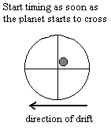Finding the diameter of a planet
You may remember from your studies of math the following bit of information. If you have a triangle that you know 2 angles and a side, it is possible to find the lengths of the other 2 sides and the size of the third angle. Using your results from the previous section, and your distance to the planet that you found in Part One, you can solve for the side of the triangle shown below which corresponds to the diameter of the planet.
Figure 6.1, planet in the eyepiece
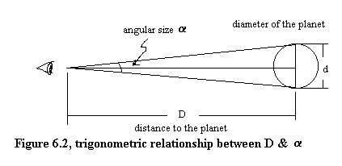
Using the trig. function tangent, the following relationship exists:
Thus, with all quantities known except for d, solve for d.

