Stars & Other Things

A Student's Guide to the Universe

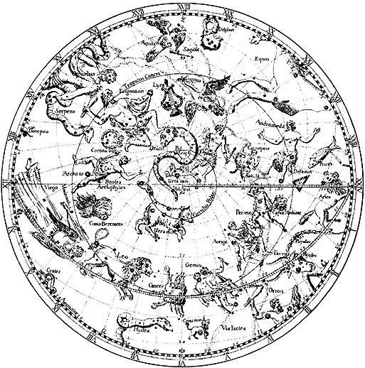

Luther W. Richardson
Auburn University
2000
Note to the Students
At first glance, this lab manual may appear to be yet another text-book approach to teaching. However, keep in mind that the subject matter is stars and planets, galaxies and moons, or in other words: space. It is very exciting stuff for little Carbon-based life forms living on a minuscule bit of space junk orbiting an average star. Included in these pages are adventures in exploring. This is the same exploring that was done by the people who discovered the true nature of our surroundings. To some students, it seems imposing and almost scary to try to grasp such knowledge. Although it may make our world seem small and insignificant, the study of astronomy rejuvenates your appreciation for learning, curiosity, and being alive.
To study the basics of the small piece of Universe about you, there are some general principles of physics that will be addressed. The best suggestion for those of you shy to mathematics is to try your best to conceptualize what is being said instead of fighting every plus and minus sign. Other than that, prepare to be introduced to the oldest science with some hands on experiences. In order to maximize the hands on stuff, please feel free to offer help in setting up equipment and putting it away. Telescopes are time consuming to set up, and TA’s love being helped!
If you have any questions or reports of errors, please contact the author at:
lrich@physics.auburn.edu

Clear skies.

Constellations and Celestial Coordinates

Objectives
Identify some major constellations and bright stars in the sky and on star maps

Use a star map and understand the coordinates and related terminology
Materials Needed
computer with Voyager 3 software, instructions, report form

Learning your way around the night sky can be likened to learning the streets of a new town. The more time you spend navigating about the stars, the better you know them. However, learning stars is somewhat more complicated than learning streets due to the motions of the Earth. For instance, imagine trying to learn the streets of a town where the streets move from one side of town to the other as the night progresses. Also, these streets will also change their location from night to night. So, at sunset, Broadway is on the east side of town; but, by sunrise, the same street is on the west side of town. The next night you note that Broadway is actually a little closer to the west side of town than the previous night until a few months later the same road is in the middle of town at sunset. What a weird town! This is what occurs with the relative positions of the stars as viewed by Earthlings because of the Earth’s revolution about its axis and rotation about the Sun. Due to these motions, stars are seasonal and they seem to rise and set.
CONSTELLATIONS
Stars are organized into formal sections of the sky called constellations. Constellations are more than recognized patterns of stars; they are also used by astronomers to divide the sky much the same way that the United States is divided into 50 states. There are 88 official constellations. Other familiar groups of stars not officially recognized as constellations are called asterisms. For example, the Big Dipper is not a constellation. It is actually part of the constellation Ursa Major (the Big Bear).
MAGNITUDES
Stars are ranked in brightness using a scale of brightness called magnitudes. This system originated from a system devised by Hipparchus in 150 B.C. He said that the very brightest stars are of the 1st magnitude and the very dimmest stars of the 6th magnitude. This same scale is used today, except photometers take out any human guessing as to which star is brightest.
The actual difference in magnitudes is not linear, rather it is logarithmic. For instance, a star with a magnitude of 3.0 is not twice as dim as a star with magnitude of 1.0. The way it works out, there is a difference of 2.512 in luminosity for every 1.0 difference in magnitude. Here is a handy equation to make the relationship make more sense:

where the funny triangle is short-hand for "change in."
Through your study of astronomy, you will encounter this magnitude system frequently. The table below illustrates some magnitude examples.
MAGNITUDES of COMMON CELESTIAL OBJECTS

Object Magnitude
SUN -26.7
Full Moon -12.5
Venus - 4.0
Jupiter - 2.5
Sirius - 1.4
Dubhe 1.0
Polaris 2.2
"dimmest star seen 4.5
from in front of Allison"

Uranus 5.8

"dimmest star seen 6.0
from outskirts of Auburn"

"dimmest star visible to 6.5
the naked eye in best
conditions"

Neptune 7.9

limit of average binoculars 9.0

Pluto 13.9

limit of the C8 14.0

BRIGHT STARS
The majority of the bright stars in the sky have been given names (most are Arabic in origin), but they are also designated based on their relative brightnesses and in which constellation they are located. The system of cataloging stars by constellation and apparent brightness was originated by Johann Bayer in 1603 and is referred to as the Bayer Designation. In this system, the Greek alphabet is used to rank the stars by brightness. These Greek characters are combined with the genitive (Latin possessive) form of the constellation name to complete the designation. For instance, α Leonis is the brightest star in the constellation Leo, while β Leonis is second brightest. Because Bayer developed his catalog so long ago without the aid of modern photodetectors , the relative brightness of stars in a few constellations was judged incorrectly. For example, Beteleguese is the second brightest star in Orion, but its Bayer designation is α Orionis. The brightest star in Orion, Rigel, is designated as β Orionis. There are a few constellations where the order was based on the positions of the stars, like Ursa Major. The Greek alphabet is given in table below

Table 1.2, The Greek Alphabet
Alpha α | Nu ν
Beta β | Xi ξ
Gamma γ | Omicron ο
Delta δ | Pi π
Epsilon ε | Rho ρ
Zeta ζ | Sigma σ
Eta η | Tau τ
Theta θ | Upsilon υ
Iota ι | Phi φ
Kappa κ | Chi χ
Lambda λ | Psi ψ
Mu μ | Omega ω

