
AUBURN UNIVERSITY PHYSICAL THERAPY
TRANSCRIPT ENTRY DOCUMENT
Please carefully follow the instructions to complete these forms. For questions, contact the program through email at dpt@auburn.edu.
b
Instructions:
Each applicant must complete the five forms included in the Transcript Entry Document as part of the AUPT application. This document must be completed electronically using Microsoft Word. All coursework entries should match the information on your official transcripts. It is the applicant’s responsibility to ensure that all information provided is complete, accurate, and truthful.
b
Required Forms:
[Form 1]: Background Information and Academic History (Page 3)
Begin by answering the background questions. Next, list each institution beyond high school that you have attended, including any dual enrollment, community colleges, undergraduate universities, and graduate schools. For each institution, include the institution name, major, degree level, GPA hours, quality points, semester and years attended, and your overall GPA. All of this information can be found on your transcript from each institution you have attended. Only use the number of rows you need, leave the extra rows blank.
b
[Form 2]: Prerequisite Coursework Log (Page 4)
All but eight hours of prerequisite courses must be complete by the end of the Fall 2025 semester of the year of application. Completion of all prerequisites and submission of official transcripts prior to matriculation on May 18th, 2026, is required. At the time of application (Aug. 1 – Sept. 30, 2025), all prerequisite coursework should be completed, in progress, or officially planned for a future academic semester.
b
For each prerequisite course, you must complete all required fields in the log and provide the following:
- Course Status: Indicate whether the course is completed, in progress, or planned.
- Attempt: Specify whether this is your first attempt or a repeated attempt taking the course.
- Course Code: Enter the official course code provided by the institution where the course was completed.
- Course Title: Provide the full title of the course (abbreviate if necessary due to space constraints).
- Credit Hours: Record the number of credit hours associated with the course.
- Grade Earned: Enter the final grade received. If the course is in progress or planned, select that option under “Grade Earned.”
- Semester and Year: Specify the term and year in which the course was completed, in progress, or planned.
- Institution: Indicate the name of the college or university where the course was or will be taken.
- b
Unique Course Log Guidelines:
- Science Lecture and Lab: If your transcript lists lecture and lab separately, record them as separate entries in your log. If they are combined, list them as a single entry in the lecture row and select “Lec/Lab Same” for the lab “Course Status” and other applicable fields on that row.
- Transfer Credit: Enter all coursework under the original institution where the course was completed, not where the credits were transferred to.
- Advanced Placement: AP Credit will count towards coursework requirements if clearly indicated as AP Credit on your official transcript.
- Term Based Institutions: If your primary institution follows a term calendar, email the program before completing this document.
- b
Prerequisite Coursework Log Examples:
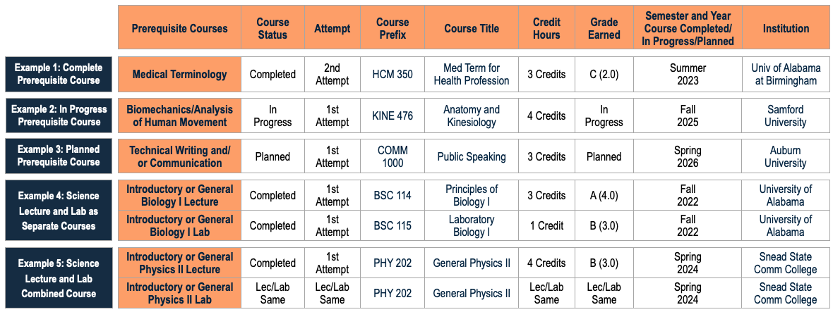

AUBURN UNIVERSITY PHYSICAL THERAPY
TRANSCRIPT ENTRY DOCUMENT

[Form 3]: Recommended Additional Coursework Log (Page 5)
List any additional recommended course you have completed. These courses are not required but are highly recommended prerequisites as well as they will contribute to an applicant’s preparation for the Doctor of Physical Therapy program.
- b
Complete this form by following the same instructions used to fill out the “Prerequisite Coursework Log.” If you do not plan to take a course listed on this log, please select, “Not Taking” for the “Course Status” and other applicable fields on that row.
b
[Form 4]: Last 60 Hours Coursework Log (Page 6)
List your undergraduate and/or graduate coursework in reverse chronological order, starting with your most recent academic semester and working backwards. Continue listing courses until you have accumulated exactly 60 credit hours.
- Do not include courses that are still in progress or planned at the time of application.
- Only include courses graded with letter grades.
- AP Credit, Pass/Fail, and Satisfactory/Unsatisfactory courses should not be listed in this calculation.
For each course, provide the course code, course title, number of credit hours, grade received, semester and year taken, and the institution where the course was completed. Once you reach 60 credit hours, stop listing courses, and leave any additional rows blank.
b
[Form 5]: Transcript Verification and Applicant Certification (Page 7)
Sign and date this form to confirm accuracy and authenticity of your academic information.
b
Additional Resources:
- For admission criteria and a list of prerequisite courses, visit the “Prospective Student” page on the Auburn University Physical Therapy website.
- Review the Transfer Equivalency Charts to see how courses from other institutions compare to Auburn University courses.
- For questions, contact the program through email at dpt@auburn.edu.

[Form 1]: Background Information and Academic History

Applicant First and Last Name:
- Date of Birth (MM/DD/YY): / /
- Current Age:
- Undergraduate Major:
- Undergraduate Minor(s) (leave blank if does not apply):
- Have you Graduated with your Undergraduate Degree: Yes No | Date of Completed or Anticipated Graduation (MM/DD/YY): / /

Background Information: Please answer the following questions by selecting Yes or No for each item.
- Are you an Auburn University graduate? Yes No
- Are you a first-generation college student? Yes No
- Are you a first-generation graduate student? Yes No
- Are you from a rural county? (If uncertain, use the United States Rural America Map to find out). Yes No | List your county: and state:

Please list each institution beyond high school, which you have previously attended. If you are currently enrolled, give the last expected date of enrollment.
Only use the number of rows you need, leave the extra rows blank.
Institution | Degree Level | Years Attended | GPA Hours Earned | Quality Points Earned | Overall GPA
 |  | , - , |  |  | / 4.0
 |  | , - , |  |  | / 4.0
 |  | , - , |  |  | / 4.0
 |  | , - , |  |  | / 4.0
 |  | , - , |  |  | / 4.0
 |  | , - , |  |  | / 4.0
 |  | , - , |  |  | / 4.0
 |  | , - , |  |  | / 4.0

Applicant First and Last Name:
[Form 2]: Prerequisite Coursework Log

Subject Area | Prerequisite Courses | Course Status | Attempt | Course Prefix | Course Title | Credit Hours | Grade Earned | Semester and Year Course Completed/In Progress/Planned | Institution
Biology  (8 credits) | Introductory or General Biology I Lecture
 | Introductory or General Biology I Lab
 | Introductory or General Biology II Lecture
 | Introductory or General Biology II Lab
Chemistry  (8 credits) | Introductory or General Chemistry I Lecture
 | Introductory or General Chemistry I Lab
 | Introductory or General Chemistry II Lecture
 | Introductory or General Chemistry II Lab
Physics  (8 credits) | Introductory or General Physics I Lecture
 | Introductory or General Physics I Lab
 | Introductory or General Physics II Lecture
 | Introductory or General Physics II Lab
Anatomy & Physiology  (8 credits) | Human or Mammalian Anatomy Lecture
 | Human or Mammalian Anatomy Lab
 | Human or Mammalian Physiology Lecture
 | Human or Mammalian Physiology Lab
Biomechanics  (3 credits) | Biomechanics/Analysis of Human Movement
Terminology  (2-3 credits) | Medical Terminology
Psychology  (3 credits) | Introductory or General Psychology
Math  (3 credits) | Introductory or Applied/General Statistics
Communication  (3 credits) | Technical Writing and/or Communication
At the time of application (Aug. 1 – Sept. 30), all prerequisites should be completed, in progress, or planned for a future academic semester.
All but eight hours of prerequisites must be completed or in progress by the end of the Fall 2025 semester.
Applicant First and Last Name:
[Form 3]: Recommended Additional Coursework Log

The Recommended Additional Coursework listed below is not required for admission
The following courses are highly recommended prerequisites as well as they will contribute to an applicant’s preparation for the Doctor of Physical Therapy program.

Recommended Additional Coursework | Course Status | Attempt | Course Code | Course Title | Credit Hours | Grade Earned | Semester and Year Course Completed/  In Progress/Planned/Not Taking | Institution
Motor Control/Behavior/Learning
Motor Development
Exercise Physiology
Introduction to Research (Research Methods)/Research Paper/Research Presentation
Exercise and Sport Psychology
Human/Child Development
Nutrition
Developmental Psychology
Introductory or General Sociology

Applicant First and Last Name:
[Form 4]: Last 60 Hours Coursework Log

This form is used to verify the most recent 60 credit hours of undergraduate and/or graduate level coursework completed. Only use the number of rows you need, leave the extra rows blank.
60
Total Credit Hours: _________
Course Code | Course Title | Credit Hours | Grade Earned | Semester and Year | Institution
 |  |  |  | ,
 |  |  |  | ,
 |  |  |  | ,
 |  |  |  | ,
 |  |  |  | ,
 |  |  |  | ,
 |  |  |  | ,
 |  |  |  | ,
 |  |  |  | ,
 |  |  |  | ,
 |  |  |  | ,
 |  |  |  | ,
 |  |  |  | ,
 |  |  |  | ,
 |  |  |  | ,
 |  |  |  | ,
 |  |  |  | ,
 |  |  |  | ,
 |  |  |  | ,
 |  |  |  | ,
 |  |  |  | ,
 |  |  |  | ,
 |  |  |  | ,
 |  |  |  | ,
 |  |  |  | ,
 |  |  |  | ,
 |  |  |  | ,
 |  |  |  | ,
 |  |  |  | ,
 |  |  |  | ,

[Form 5]: Transcript Verification and Applicant Certification

Statement on Accuracy and Integrity:
Please review this document carefully and ensure that all information provided is complete, accurate, and truthful. By signing below, the applicant certifies that all academic information included in this application is their own and aligns with their official transcript(s).

Any falsification, omission, or misrepresentation of information provided during the admissions process may result in immediate disqualification. If such actions are discovered after admission, they may lead to disciplinary action, including possible dismissal from the Auburn University Doctor of Physical Therapy Program

Applicant Attestation:
I hereby affirm that all information provided in this application are true, complete, and accurate to the best of my knowledge. I understand that any misrepresentation, omission, or falsification may result in the denial of admission or, if discovered after enrollment, disciplinary action up to and including dismissal from the program.

Applicant Full Name (Typed):

Applicant Signature (Typed):

Date (MM/DD/YY): / /

Transcript Entry Document Submission Guidelines

- Fully complete the form before submission.
- Save the completed form as a PDF document.
- Name the PDF document using the following format: “Last Name, First Name” (Example: Smith, Jane).
- Submit the finalized PDF through the Graduate School Application Portal as part of your application.

Page 7 of 7

