Family Child Care Partnerships

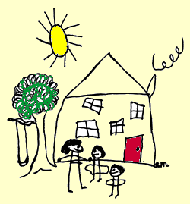

FCCP Main Office Toll Free: 1-877-892-FCCP

109 M. White Smith Hall Fax: 334-844-3734

Auburn, AL 36849 www.humsci.auburn.edu/fccp

# FCCP Training Hours

**Request for**

**Group Home Provider Assistants**

Participating group home providers may apply for training hours to be issued to their assistants for participating in the FCCP program. Training hours will be awarded quarterly to providers and assistants based on signatures on the FCCP Daily Partnership Activity Reports.

In order for our office to properly process the Daily Partnership Activity Reports and award training hours to assistants, we need a record of these assistants on file. Training hours will be entered into our computer system AFTER we receive this application.

Please complete the following information on your Group Home assistant. (If you have more than one assistant, please complete a separate form for each.)

Date ____________________________________

Participating Provider____________________________________ FCCP ID Number ____________

Provider’s Signature_________________________________________________________________

****************

Assistant’s Name (printed) ___________________________________________________________

Assistant’s Signature ________________________________________________________________

*****************

Mentor’s Signature _________________________________________________________________

Make note if former Assistant should be removed from database _____________________________

**FCCP Office Use Only**

Date Code Assigned/entered in system ______________________

____________________________

ID Number

*Rev. 7/30/12 ebm*