**Seed EFFICIENCY INCREASED BY USING pine bark mulch**

**at Time of Sowing LOBLOLLY PINE**

by

Paul Jackson and David South

It is known that applying pendimethalin (Pendulum® AquaCap™ ) 4 to 8 weeks after sowing can cause galls to form at some nurseries (South and Hill 2009; 2010). We expect some environmental factors might explain why galls occur at some nurseries and not others. For example, the use of pine bark mulch can mitigate the effect of certain herbicides on pine seedlings (South 1988). It was speculated that the galls observed at sowing in previous trials may have occurred when the herbicide came into contact with seed that had already germinated and were vulnerable to injury. In 2010, three studies were installed to determine if herbicide galls would form on seedlings when pendimethalin was applied over pine bark. The primary null hypothesis was: pine bark mulch (applied before the herbicide treatment) does not affect gall formation on loblolly pine (*Pinus taeda*) seedlings. The secondary null hypothesis was: pine bark mulch does not affect production of loblolly pine seedlings.

**METHODOLOGY**

Herbicide trials that involved a pine bark treatment were conducted in Camden, AL, Elberta, AL and Trenton, SC during the 2010 growing season. Pendulum® AquaCap™ (68 oz of product per acre; 2 lb a.i./acre) was applied with and without pine bark mulch at time of sowing (Table 1). Herbicide treatments were applied using a CO2 backpack sprayer calibrated to deliver 22 gallons per acre. Herbicide treatments were replicated five times with plots being one bed wide and 10 feet long. The pine bark was distributed onto plots prior to Pendulum® AquaCap™ treatment (Figure 1). Nylon rope was stretched in the center of each plot and secured with nails at each corner to form a 2 ft2 perimeter to keep the pine bark from washing. Soil samples were collected from each plot to determine soil texture, pH, and organic matter levels at each nursery (Table 2).

At the end of the growing season, seedlings were lifted using a 1 x 4 ft counting frame that was centered in each plot. At the Nursery Cooperative laboratory, seedling densities (i.e. number of seedlings per square ft) and the number of culls (< 3.2 mm root collar diameter (RCD)) or plantable seedlings (≥ 3.2 mm RCD) were recorded. Seedling height and root collar diameter were measured on 25 plantable seedlings, and oven dry weights of shoots and roots were recorded for each 25-seedling sample. The root dry weight ratio was calculated by dividing the weight of the roots by the weight of the entire seedling and gave an evaluation of overall root quality. The seedlings were also examined for herbicide galls (i.e. swellings) at the root collar. Data were analyzed using Analysis of Variance (ANOVA) and differences were determined using an F-test. Significant differences were determined using an alpha value of 0.05.

**RESULTS**

At the time of lifting, herbicide galls were not detected on any of the seedlings evaluated from each of the three nurseries. Therefore, this study was unable to provide a valid test the primary hypothesis.

Overall, the pine bark treatment increased seed efficiency and the number of plantable seedlings (Table 3). The increase in crop value ranged from 8% at the Elberta Nursery (Figure 2), to 20% at the Camden nursery (Figure 3) to 25% at the Trenton Nursery (Table 4). The pine bark treatment reduced the root-collar diameter (Table 3) but this may be related to the lower stand density in non-mulched plots. The samples taken from plots with pine bark had 2 more seedlings per square foot.

**mANAGEMENT IMPLICATIONS**

Some nursery managers apply pine bark mulch to nursery beds to keep seedlings cooler and to assist in retaining soil moisture. In some years, this can increase crop value. In 2010, the use of pine bark increased crop value by 18%. An increase of 2 plantable seedlings per square foot might increase crop value by $2,900 per acre.

**References**

South, D.B. 1988. Bark mulch and Cobra reduce lesion formation. Auburn University Southern Forest Nursery Management Cooperative. Newsletter (Spring).

South, D.B. and T.E. Hill. 2009. Results from six *Pinus taeda* nursery trials with the herbicide pendimethalin in the USA. Southern Forests 71(3): 179-185.

South, D.B. and T. Hill. 2010. Tolerance of loblolly and slash pine seedlings to pendimethalin. Auburn University Southern Forest Nursery Management Cooperative. Research Report 10-04: 9

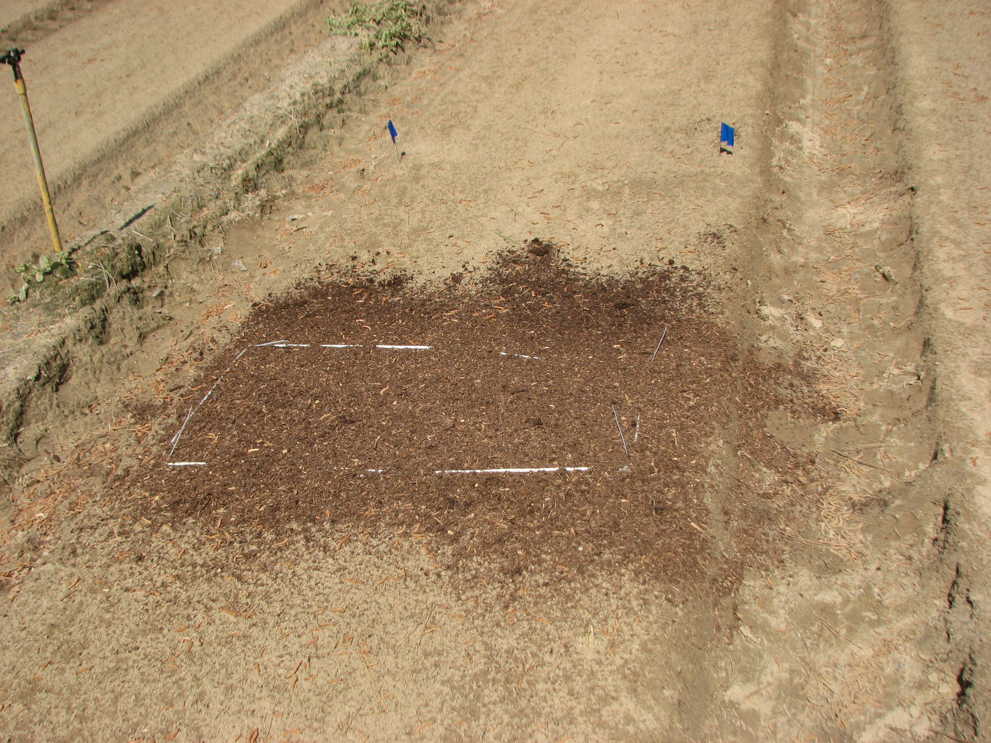

Figure 1. Bark plot at the Trenton Nursery before the application of herbicides.

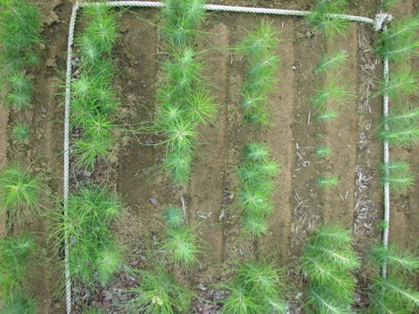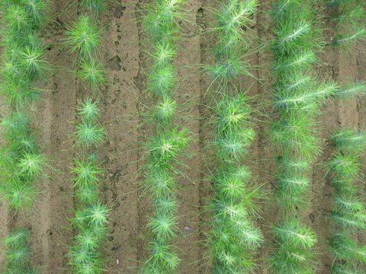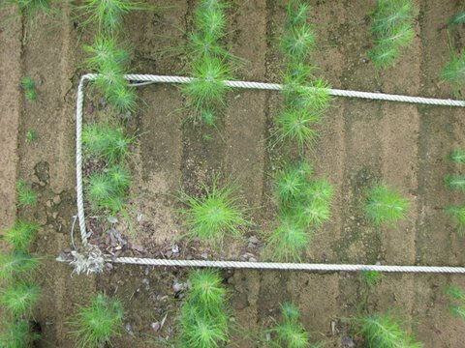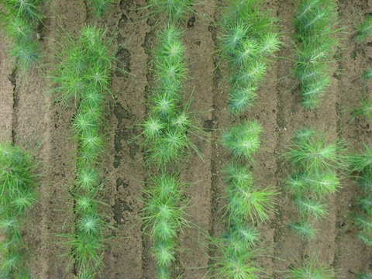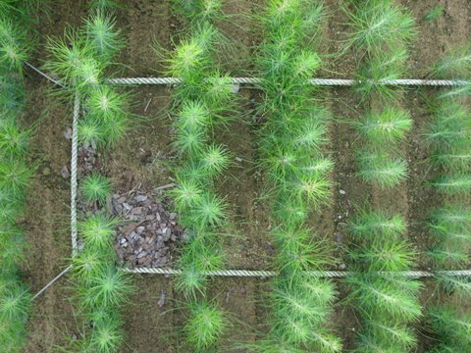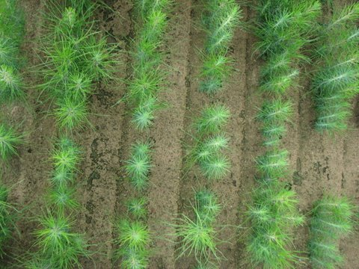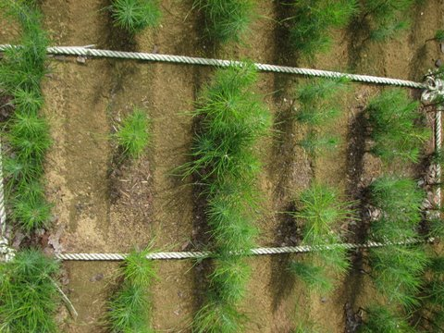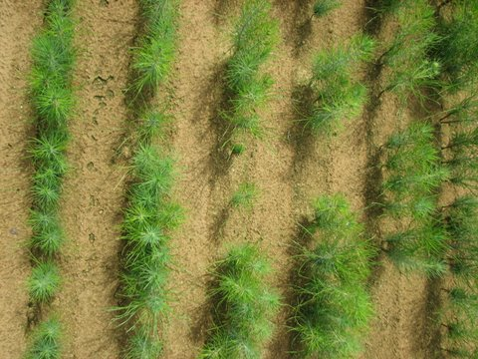

Figure 2. Bark plots (left) paired with control plots at the Elberta Nursery.

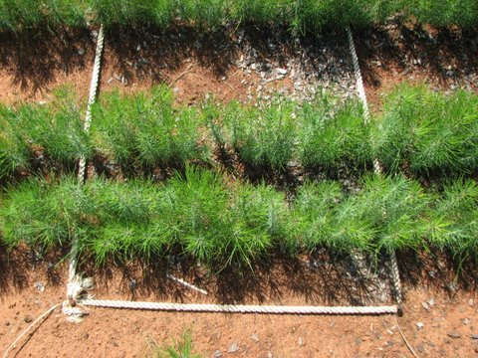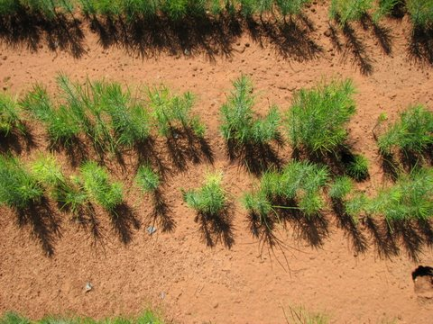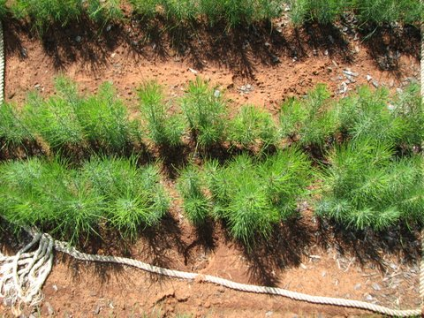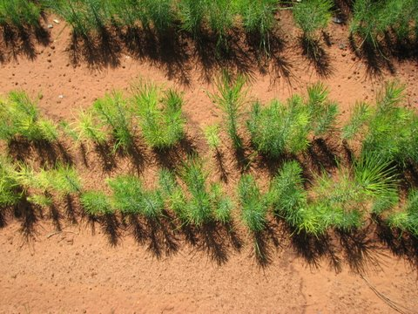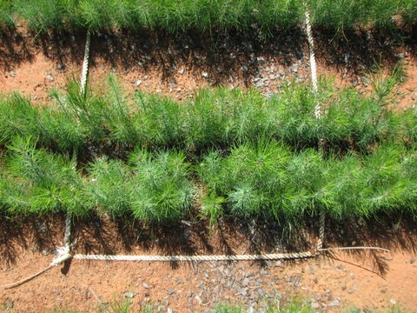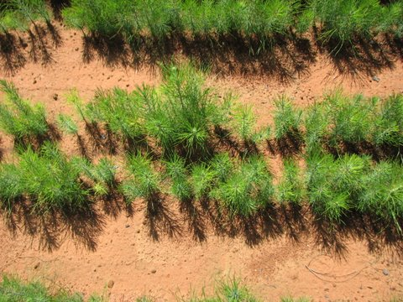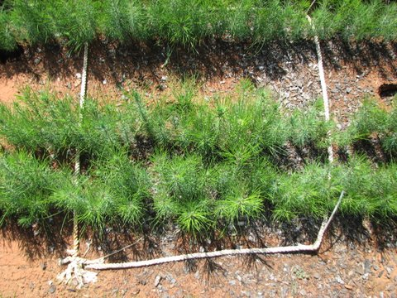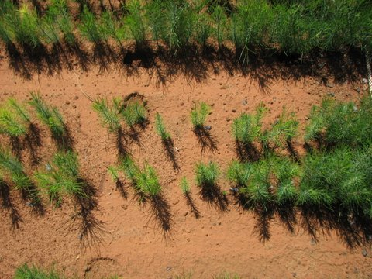

Figure 3. Bark plots (left) paired with control plots at the Camden Nursery.

**Table 1.** The date of sowing, herbicide treatment, and seedling lifting at each nursery in 2010.

|  |  |  |  |  |
| --- | --- | --- | --- | --- |
| **Nursery** | **Species** | **Sow date** | **Treatment date** | **Lift date** |
| Camden | Loblolly | 4/20 | 4/20 | 11/8 |
| Elberta | Loblolly | 4/22 | 4/26 | 12/1 |
| Trenton | Loblolly | 4/6 | 4/12 | 11/15 |

**Table 2.** Soil pH, texture, and organic matter (OM) at each nursery in 2010.

|  |  |  |  |  |  |  |
| --- | --- | --- | --- | --- | --- | --- |
|  |  |  | **%** | | | |
| **Nursery** | **pH** | **Texture** | **Sand** | **Silt** | **Clay** | **OM** |
| Camden | 4.8 | sandy loam | 67.6 | 17.9 | 14.4 | 1.3 |
| Elberta | 5.3 | sandy loam | 77.2 | 16.3 | 6.4 | 2.0 |
| Trenton | 5.1 | sand | 88.8 | 8.8 | 2.4 | 1.9 |

**Table 3.** The number of culls and plantable seedlings and seedling density, height, root collar diameter (RCD), root dry weight, shoot dry weight and root dry weight ratio (RWR) for loblolly pine seedlings (mean of three nurseries).

|  |  |  |  |  |  |  |  |  |  |
| --- | --- | --- | --- | --- | --- | --- | --- | --- | --- |
| **Treatment** | **Rate** | **Culls (#/ft2)** | **Plantable (#/ft2)** | **Density (#ft2)** | **Height (cm)** | **RCD (mm)** | **Root Wt (g)** | **Shoot Wt (g)** | **RWR (%)** |
| Pendulum AquaCap | 2X | 2.6 | 12.2 | 15.0 | 27.3 | 4.87 | 1.03 | 3.91 | 20.9 |
| Pendulum AquaCap + Pine bark | 2X | 2.9 | 14.5 | 17.4 | 27.5 | 4.64 | 0.94 | 3.67 | 20.5 |
| LSD* |  | *1.1* | *1.6* | *1.9* | *1.1* | *0.20* | *0.12* | *0.43* | *1.6* |
| **Source** | **df\*\*** | **P > F** | | | | | | | |
| Treatment | 1 |  |  |  |  |  |  |  |  |
| Location | 2 |  |  |  |  |  |  |  |  |
| Error | 26 |  |  |  |  |  |  |  |  |

* Least significant differences are italicized; ** Degrees of freedom

Table 4. The number of culls and plantable seedlings and seedling density, height, root collar diameter (RCD), root dry weight, shoot dry weight and root dry weight ratio (RWR) for loblolly pine seedlings, by nursery location.